

|  |  |  |  |  |  |  |
| --- | --- | --- | --- | --- | --- | --- |
| Value | **5** | **7** | **7** | **8** | **8** | **10** |
| index | [0] | [1] | [2] | [3] | [4] | [5] |



**End**

**Start**

|  |  |  |  |  |  |  |
| --- | --- | --- | --- | --- | --- | --- |
| Value | **5** | **7** | **7** | **8** | **8** | **10** |
| index | [0] | [1] | [2] | [3] | [4] | [5] |

**Mid**

|  |  |  |
| --- | --- | --- |
| Value | **5** | **7** |
| index | [0] | [1] |

**End**

**Start**



**Mid**

|  |  |  |
| --- | --- | --- |
| Value | **5** | **7** |
| index | [0] | [1]  **Start** |

**End**

**Mid**

|  |  |  |  |  |
| --- | --- | --- | --- | --- |
| Value | **7** | **8** | **8** | **10** |
| index | [2]  **Mid** | [3] | [4] | [5] |

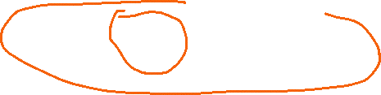

**End**

**Start**

|  |  |  |  |  |
| --- | --- | --- | --- | --- |
| Value | **7** | **8** | **8** | **10** |
| index | [2] | [3] | [4] | [5] |

**Mid**

**End**

**Start**

|  |  |  |  |  |
| --- | --- | --- | --- | --- |
| Value | **7** | **8** | **8** | **10** |
| index | [2] | [3] | [4] | [5] |

**End**

**Start**

**Mid**

|  |  |  |
| --- | --- | --- |
| Value | **7** | **8** |
| index | [2]  **End** | [3]  **Start** |

**Mid**

|  |  |  |
| --- | --- | --- |
| Value | **7** | **8** |
| index | [2]  **End** | [3] |

**Mid**

**Start**

**Find First**

**Find Last**